Steps to configure NFS (Network File System)
- Mount CD1.
- Install nfs package:
#Rpm-ivh /mnt/cdrom/RedHat/RPMS/nfs*
- #Service nfs start
#service portmap start
Service nfslock start
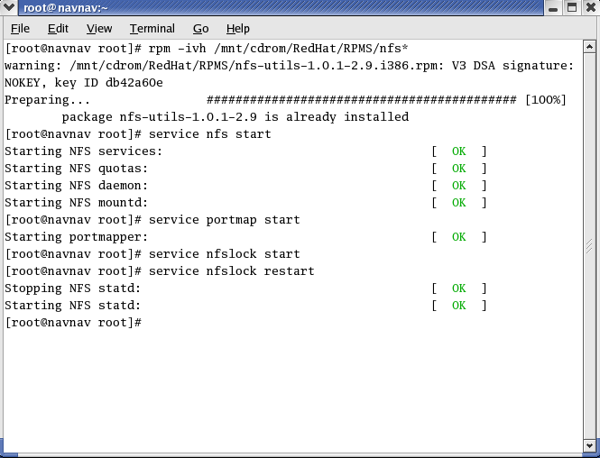
- Change directory
# cd /
- #mkdir /nfsserver
#ls
#touch /nfsserver/demo1
#touch /nfsserver/demo2
#ls /nfsserver
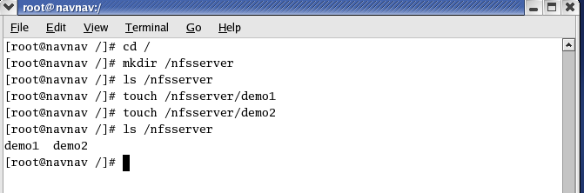
- #gedit /etc/exports
Write directory name to this file as follows:
/nfsserver *(rw,sync)

Save the file and close it.
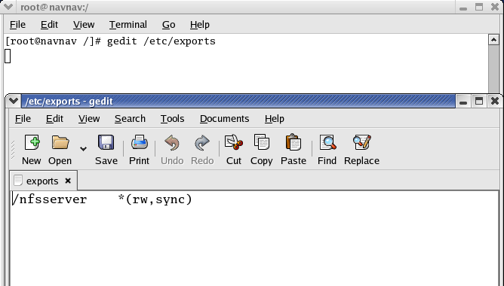
- #service nfs restart
#service portmap restart
#Service nfslock restart
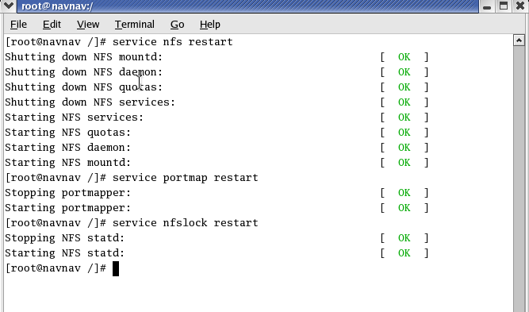
- #showmount –e 192.168.192.129 //(write ip address of nfs server)
#exportfs –r
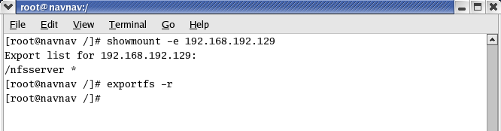
- Open a new terminal, change directory, create a nfsclientt directory in / and check the list of files in it. This directory is empty at this time.
# cd /
#mkdir /nfsclient
#ls /nfsclient

nfsclient directory is empty
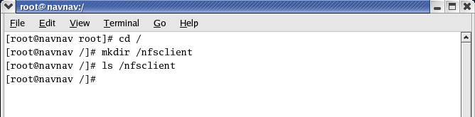

- Mount –t nfs IP address :/nfsserver /nfsclient
- Now type
# ls /nfsclient
It will show two files demo1 and demo2 which were created in directory nfsserver.

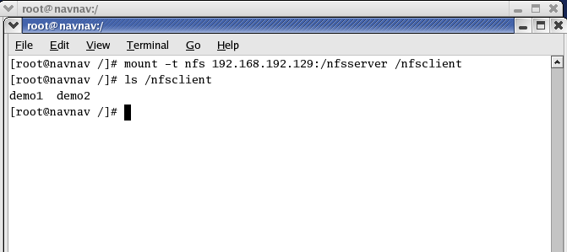

For linux to windows(Cross platform)
- In programs and featrures strat NFS services
- Open cmd write
  - Mount –o ipaddroflinus:/nfsserver W:

(W: is a drive letter for windows file system)
W: is a directory letter for linux mounting(share data)
Output: It will map with all shared dir of server

